# AI ASSISTED CODING

## ASSIGNMENT-9.3

ERUKULA SAMPATH

2403A51270

BATCH-12

**TASK-1**

Basic Docstring Generation

• Write python function to return sum of even and odd numbers in the given list

• Incorporate manual docstring in code with Google Style.

• Use an AI-assisted tool (e.g., Copilot, Cursor AI) to generate a docstring describing the function.

• Compare the AI-generated docstring with your manually written one

**PROMPT-**

Generate a Google-style docstring for the following Python function that calculates and returns the sum of even and odd numbers in a given list. The docstring should include a short description, parameters with type hints, and return values with type hints. Do not include input-output examples.

**CODE-**

**AI GENERATED DOCSTRING-**

**OUTPUT-**

**COMPARISON-**

* **Manual Docstring (Google Style)**
  + More structured.
  + Includes **type hints** (list[int], tuple[int, int]).
  + Provides an **Example** for clarity.
* **AI-Generated Docstring**
  + Simpler, less detailed.
  + Doesn’t specify **types precisely** (just says list and tuple).
  + Lacks example usage.

👉 **Conclusion:** The manual version is more professional and precise, while the AI one is shorter and easier to write but misses some details

**TASK 2-**

Write python program for sru_student class with attributes like name, roll no.,  
hostel_status and fee_update method and display_details method.  
• Write comments manually for each line/code block  
• Ask an AI tool to add inline comments explaining each line/step.  
• Compare the AI-generated comments with your manually written one.

**MANUAL COMMENTS-CODE-**

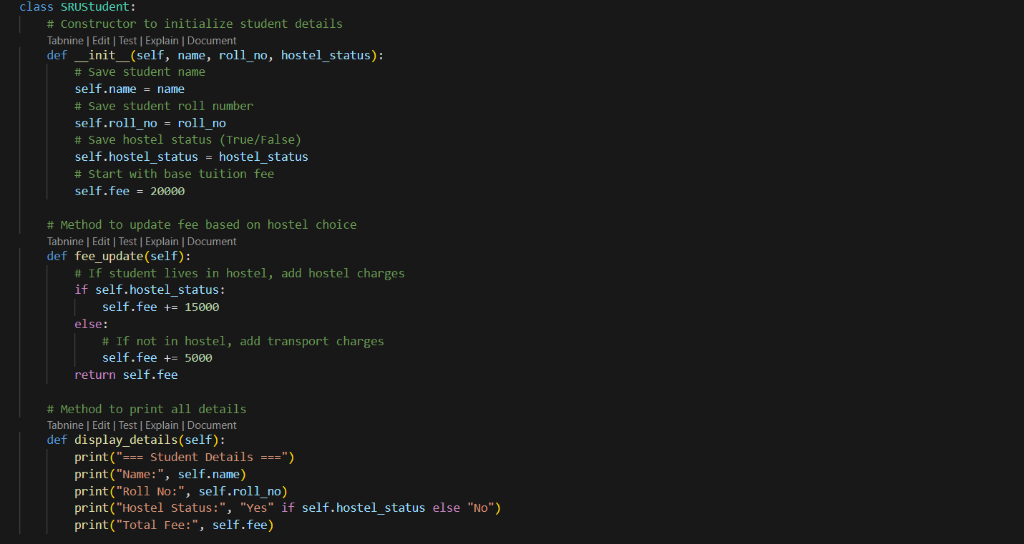

**OUTPUT-**

**PROMPT-**

Add inline comments to this Python class SRUStudent which has attributes like name, roll no., hostel_status, and methods fee_update and display_details. The comments should explain each line or step in simple terms

**CODE-**

**OUTPUT-**

**TASK 3-**

Write a Python script with 3–4 functions (e.g., calculator: add, subtract, multiply,  
divide).  
• Incorporate manual docstring in code with NumPy Style  
• Use AI assistance to generate a module-level docstring + individual function  
docstrings.  
• Compare the AI-generated docstring with your manually written one.

**PROMPT-**

Write a module-level and function-level docstring in NumPy style for a Python calculator with functions add, subtract, multiply, and divide. Include parameter types, return types, and error handling.

**CODE-**

**OUTPUT-**

